Assignment 23.2

Delayed_Flights.CSV Dataset:

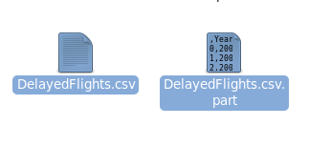

Problem Statement1:

Find out the top 5 most visited destinations:

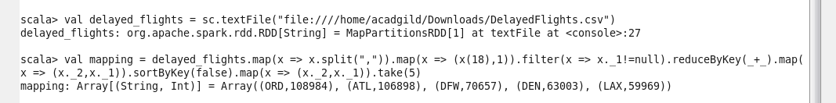

Problem Statement2:

Which month has seen the most number of cancellations due to bad weather?

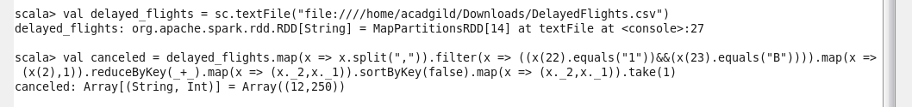

Problem Statement3:

Top ten origins with the highest AVG departure delay:

Problem Statement4:

Which route (origin and destination) has seen the maximum diversion?

